Guided Capstone Project Report

Problem Statement

Big Mountain Resort needs to implement a new strategy for its ticket pricing that corresponds to the facilities that the resort provides. Based on the analysis of the available data, our model suggests that the current ticket price of $81 is undervalued for the facilities provided and in comparison with the competitors. This report explores how facility attributes affect ticket pricing and models scenarios that could justify price increases.

Data Wrangling

We worked with dataset of ski resorts in North America. It included details about the facilities provided by each ski resort. If any values were missing, we removed them to keep the analysis accurate and checked the genuineness of the outlier values of features. This was done to keep the analysis accurate. We then focused on Big Mountain Resort’s data to test different scenarios.

Exploratory Data Analysis

We visualized key features to understand Big Mountain's position relative to competitors. Big Mountain resort was often found to be in an above average level in features like vertical drop, total runs, etc.. The graphical representation of position of Big Mountain for vertical drop is shown below.

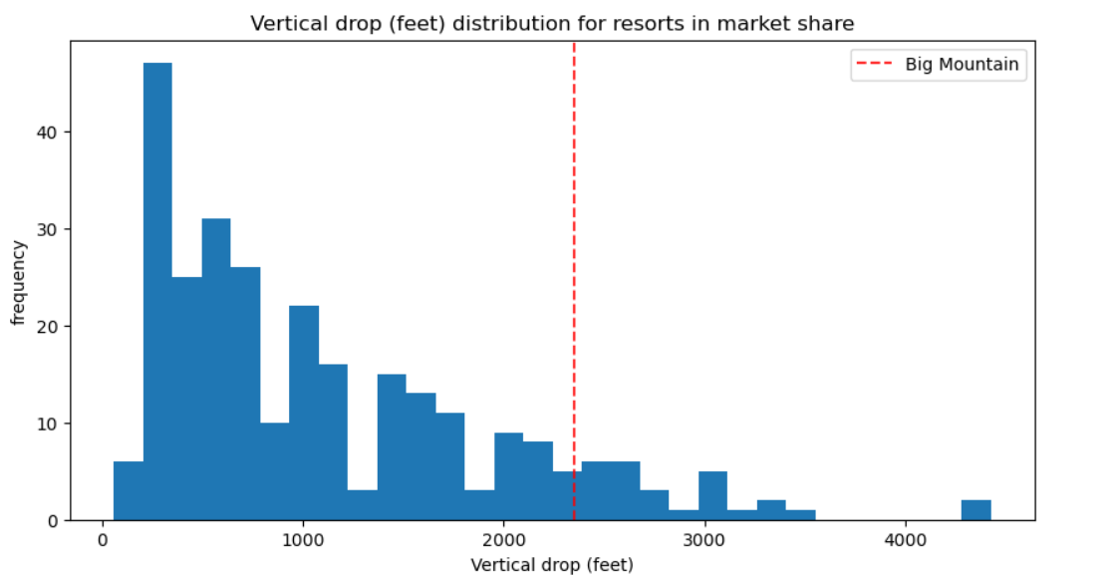

Model Preprocessing & Feature Engineering

We standardised key features so that they can be compared easily and selected the features based on correlation with ticket price. Features such as vertical drop, number of runs, snowmaking acreage, total chairs and fast quads were found to be relevant in multiple models.

Algorithms & Evaluation Metrics

For this we trained multiple regression models like Linear Regression and Random Forest. Random Forest performed well in capturing relation between resort facilities and ticket prices. R-Squared and Mean Absolute Error were used as evaluation metrics.

Winning Model & Scenario Modelling

So, the Random Forest was found to be most effective in capturing relationship between resort facilities and ticket prices. The model is also used to simulate prices under different scenarios. The different scenarios we tried out were

1. Closing Least Used Runs

* Closing up to 10 runs could reduce ticket price by $1.81.
* Estimated revenue loss varies up to $3M depending on the number of runs closed.

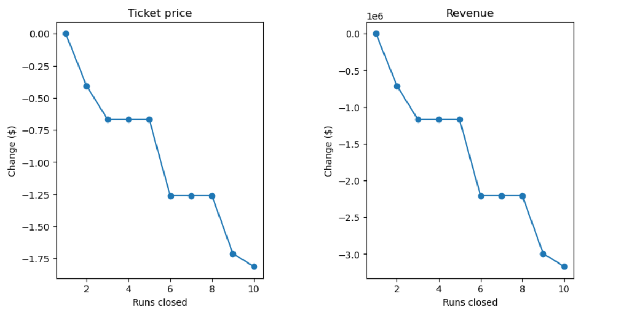

1. Adding Vertical Drop and Chairlift

* Increasing vertical drop by 150ft and adding one chairlift increase ticket price by $1.99.
* The total revenue over the season is expected to be $3.47M.

1. Adding 2 acres of snow making to second scenario

* There is no change after adding 2 acres of snow making.

1. Adding snow making by 4 acres and extending longest run by 0.2 miles

* This doesn’t have any impact in the ticket pricing.

Pricing Recommendation

The current ticket price of the model is $81.00. Based on the trained data, the model estimates a ticket price of $95.87. But there is a Mean Absolute error of $10.39. Thus, the price range can vary from $85.48 to $106.26. So, the resort should come up with a ticket price that is between this range and should ensure the customer satisfaction for the selected price.

Conclusion

Big Mountain Resort is currently charging less based on the facilities offered by the resort. Increasing vertical drop and number of chairs could support price increase with positive revenue impact.

Future Scope of Work

* Integrate guest satisfaction data to evaluate the new price.
* Develop a simple application of the model for the business analysts to work with the model easily.